Japanese American Internment

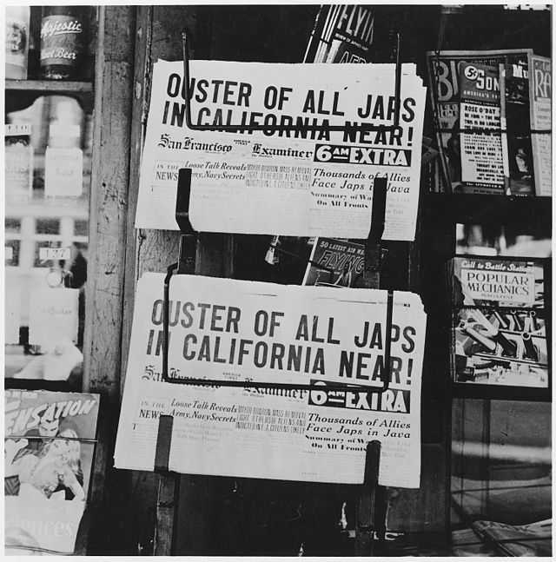

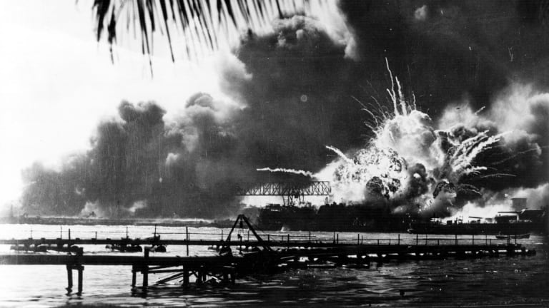

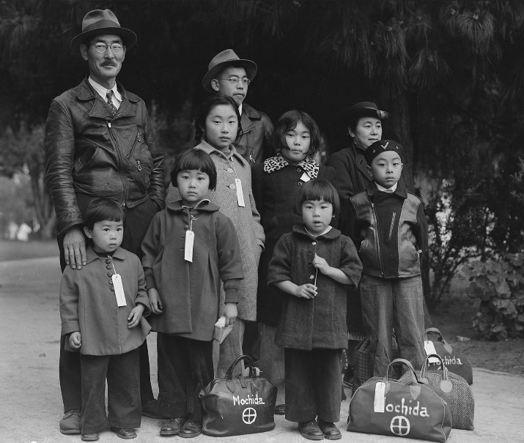

Document Based Questions
Document 1: Admiral Osami Nagano, Japan, September 6, 1941

“From the standpoint of the Imperial General Headquarters, based on the assumption that a peaceful solution has not been found and war is inevitable, the Empire’s oil supply, as well as the stockpiles of many other important war materials, is decreasing day by day with the result that the national defense power is gradually diminishing. If this deplorable situation is left unchecked, I believe that, after a lapse of some time, the nation’s vitality will deteriorate and ultimately fall into dire straits.”
--Admiral Osami Nagano, Tokyo, Japan, September 6, 1941

- What is your interpretation of the text? Support your response.
The text is an update on the ongoing of the war and the resolve that the headquarters have agreed are the best way of handling the situation. This is supported by the text, it’s clear that the situation was critical and the war was really exhausting their recourses in an alarming way.

- What does the text tell us about the time and place of its creation?
It alarms us of the effects of war, it shows formality so the place of creation is probably a meeting at the headquarters. The military supplies were running low and the country couldn’t afford the expenses and it seems war was inevitable.

- Can you elaborate on the reason that Japan’s oil and war supplies are decreasing so rapidly?
The japan oil and war supply was decreasing due to the war, attacks that
Lead to loss of their soldiers as well as supplies. The attacks were airborne and cost
Were quite high, maintaining this supplies for a long time was crippling them
Resources.

- Can you formulate a theory as to what Japan might do next? Support your response.
Japan needs to make a move and time is really not on their side, they should
Come up with a mega offensive attack that will slow down the opponent’s attack,
This would give them enough time to regroup on supplies. This is supported by the
urgency of the text meaning urgent action needs to be taken

Document 2: Executive Order No. 9066

Executive Order No. 9066
The President
Executive Order
Authorizing the Secretary of War to Prescribe Military Areas

“….Now, therefore, by virtue of the authority vested in me as President of the United States, and Commander in Chief of the Army and Navy, I hereby authorize and direct the Secretary of War, and the Military Commanders whom he may from time to time designate, whenever he or any designated Commander deems such action necessary or desirable, to prescribe military areas in such places and of such extent as he or the appropriate Military Commander may determine, from which any or all persons may be excluded, and with respect to which, the right of any person to enter, remain in, or leave shall be subject to whatever restrictions the Secretary of War or the appropriate Military Commander may impose in his discretion.”

- What is your interpretation of the text? Support your response.
The text is an executive order issued by the president giving the secretary
of war the authority to restrict areas and designate constraints of movement and
possible supervisions of individuals as deemed appropriate by the secretary of war.
This is supported by the order given by the president as implied by the text.

- What circumstances influenced the creation of this text?
The events that happened at the pearl harbor led to the creation of this text
this was to make sure there were no espionage activities happen.

- What group of people will be primarily targeted by this Executive Order? Refer back to Document 1 for help.
This text targets Americans’ with Japanese ancestry and Japanese.
They are targeted as they are thought to be likely suspicious and monitored to
Ensure they don’t engage in espionage.

- Do you agree or disagree with the enforcement of Executive Order No. 9066? Explain your response.
I disagree with the enforcement of this order as it violates the rights of the
Japanese Americans’ despite some of them being American citizens, I think this is
Institutionalized discrimination based on origin.

Document 3: Western Defense Command and Fourth Army Wartime Civil Control Administration flyer.

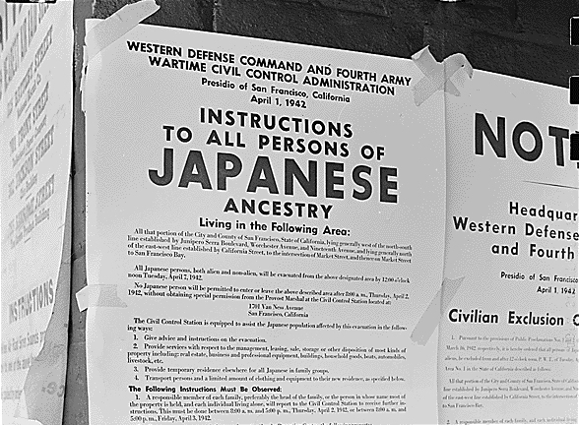

- What event(s) led to the creation of this flyer?
The creation of this flyer follows executive order issued by the president
on designation of military areas to monitor Japanese Americans’.

- How were the rights of Japanese Americans restricted during World War 2?
The individuals were restricted from moving and monitored, camps
were setup where they were rounded up and brought for scrutiny.

- How would you test the effectiveness of the Executive Order? Explain.
The effectiveness of the order was enforced by the law and they were able to
Monitor and gather the people of Japan ancestry. this can be seen by assessing the
Population of Japanese Americans’ even today.

- Which is more important, National Security, or Civil Liberties? Explain your reasoning.
It is important to ensure national security, it’s the only right that this should be done while ensuring that the civil liberties are observed since the national security would be useless without the people to protect.

Document 4: Justice Hugo Black, decision of Korematsu v. United States (1944)

“Korematsu was not excluded from the military area because of hostility to him or his race. He was excluded because we are at war with the Japanese Empire, because the… authorities feared an invasion of our West Coast and felt constrained to take proper security measures.”
--Justice Hugo Black, decision of Korematsu v. United States (1944)

- Based on this excerpt why did the court restrict Korematsu’s rights?
According to the excerpt, he was denied his right since he disobeyed the Executive order 9066 that was relocating them. The American military authorities also feared an attack by japan on the west coast and sensed the fear of their security measures. The military agencies commanded that the Japanese be temporarily isolated from the west coast to increase confidence in the military during the war. Also, Korematsu was a Japanese American who feared since he was an American citizen by registration and not by birth.

- How fully does this text represent American from 1941-44? Explain.
This fully represents America during world war two where America was at war with the Japanese and Germans. This came after the Green incident of 1941, where Roosevelt, the American president, signed a law and deployed the American military to replace the British army in Iceland. Therefore, the statement shows how the Americans were at war with the Japanese, and they feared their invention. Thus, the American military was forced to relocate all the Japanese, Germans, and Italians in America to designated areas to safeguard and secure the west coast.

- What might have been a motivation for Korematsu to try to join the American armed forces?
Korematsu was motivated to join the American army since he was an American citizen, a Japanese American who was a loyal citizen of his country. Since Korematsu was a Japanese American, they felt it secure for him to join the American army to end racism and prove to white Americans that all races are equal to the task. This is what motivated him to choose the job since he loves his country America.

- What would have happened to Japanese Americans if Japan had not bombed Pearl Harbor? Explain.
The Japanese would have stayed in residential areas and could not be relocated by the
American army. The relocation of the Japanese American to relocation centers followed the attack of Japan by bombing Pearl Harbor. It made American president Roosevelt sign an executive order of 9066 that ordered all the Japanese to vacate from their home to internment camps for the Americans to secure the west coast. In my view, the Japanese Americans could live peacefully in their home areas and could not be relocated. Their attack led to their mandatory relocation by the American army.

